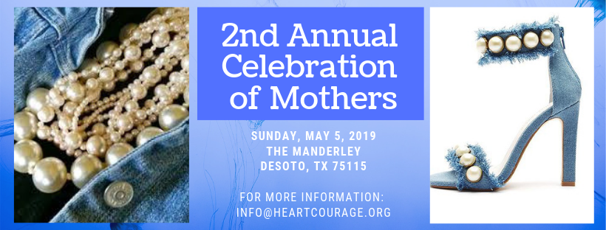
Heart of Courage
Sponsorship Form

Name: ____________________________________ Title: ______________________________
Company: ____________________________________________________________________
Address: _____________________________________________________________________
City/State/Zip Code: ____________________________________________________________
Phone: _________________ Email: ______________________________

SPONSORSHIP LEVELS
Gold Heart - $1,000
- 4 Tickets VIP Seating
- Recognition on Heart of Courage website
- Recognition on all social media outlets
- Half page ad in program book

Diamond Heart - $2,500
- 10 Tickets VIP Seating
- Recognition on Heart of Courage website
- Recognition on all social media outlets
- Full page ad in program book
- Opportunity to display company information

Giving Heart - $250
- 10 Tickets for mothers in local shelters
- Recognition on Heart of Courage website
- Recognition on all social media outlets

Silver Heart - $500
- 2 Tickets VIP Seating
- Recognition on Heart of Courage website
- Recognition on all social media outlets
- Quarter page ad in program book

- Fu

*All Sponsors are welcome to supply company information or items to be placed in guest gift bags.
PROGRAM AD BOOK
Quarter Page Ad - $15

Half Page Ad - $25

Full Page Ad - $50

Patron Ad - $5

Business Card Ad - $10

For patron ad, please list my name as (Please print).
__________________________________________________________________________
Please make online payments through this safe and secure site: ONLINE PAYMENTS
Please make checks payable to:
Heart of Courage
P.O. Box 1794
DeSoto, TX 75123
You may contact us at (972) 920-6510.
Thank you for your support!!!

